**EXPERIMENT-5**

**TRACE ROUTE**

**AIM:**

Using TraceRoute, ping, ifconfig(LINUX), ipconfig(WINDOWS), and netstat Command.

**PROCEDURE:**

* Open windows command prompt and Type tracert command and type tracert www.saveetha.com -> “Enter” .
* Type ping command and type IP Address press “Enter” .
* Type ifconfig command .
* Type netstat command.

**OUTPUT:**

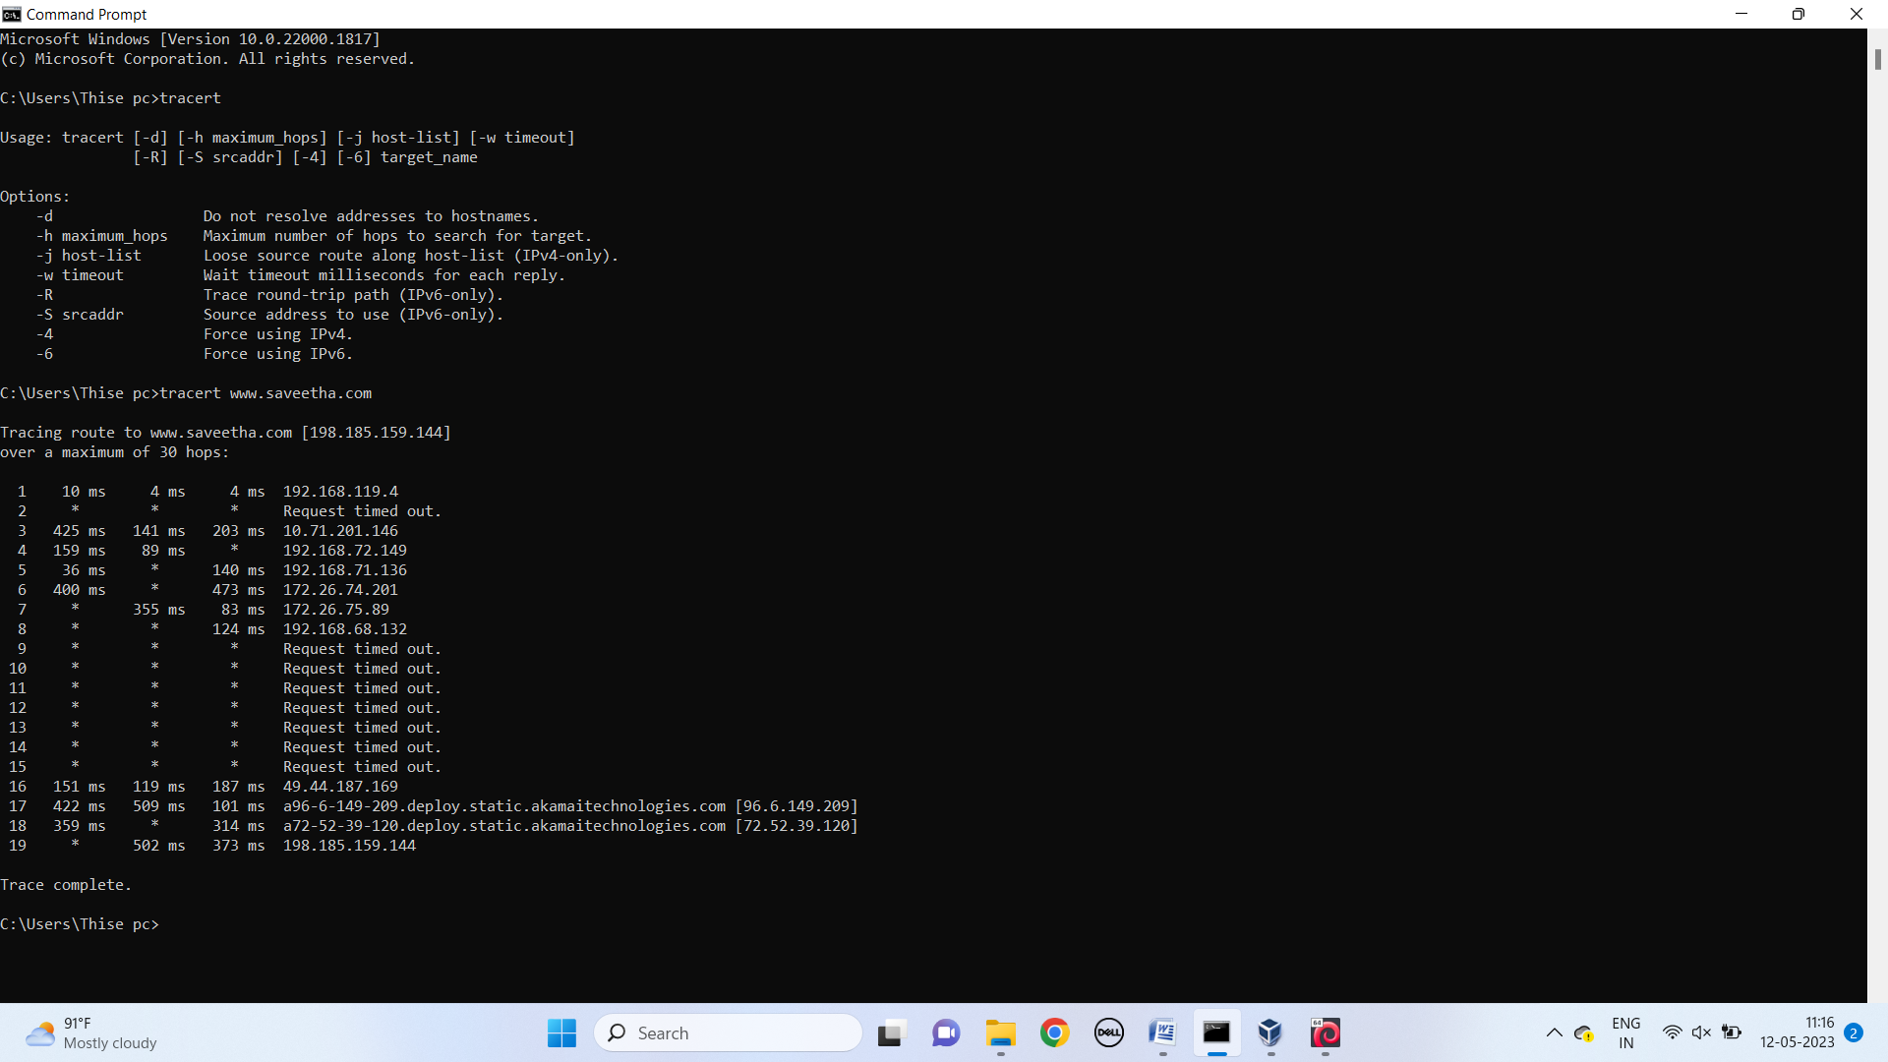

**RESULT:**

Hence the above commands are executed successfully.